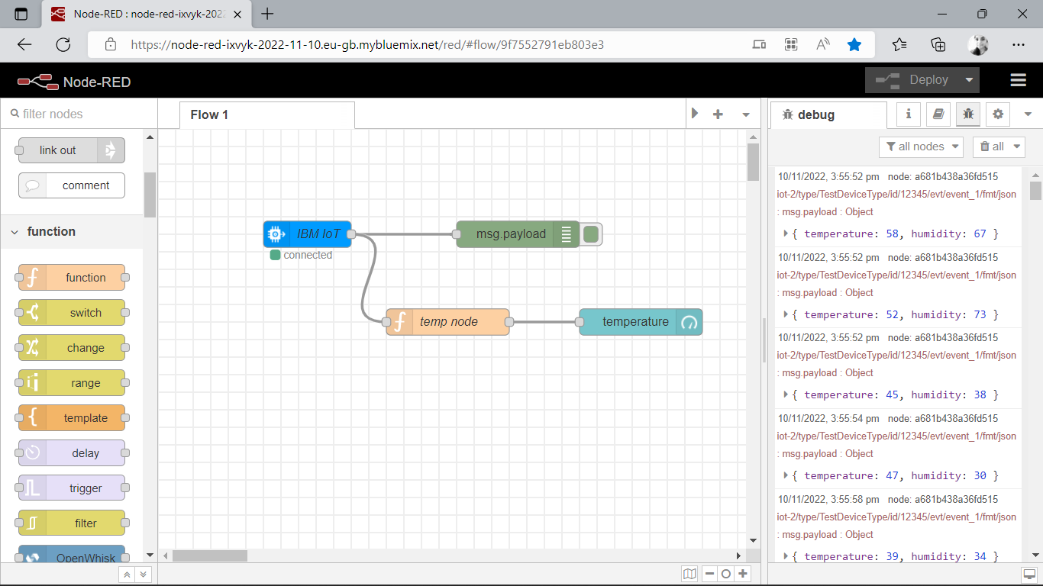

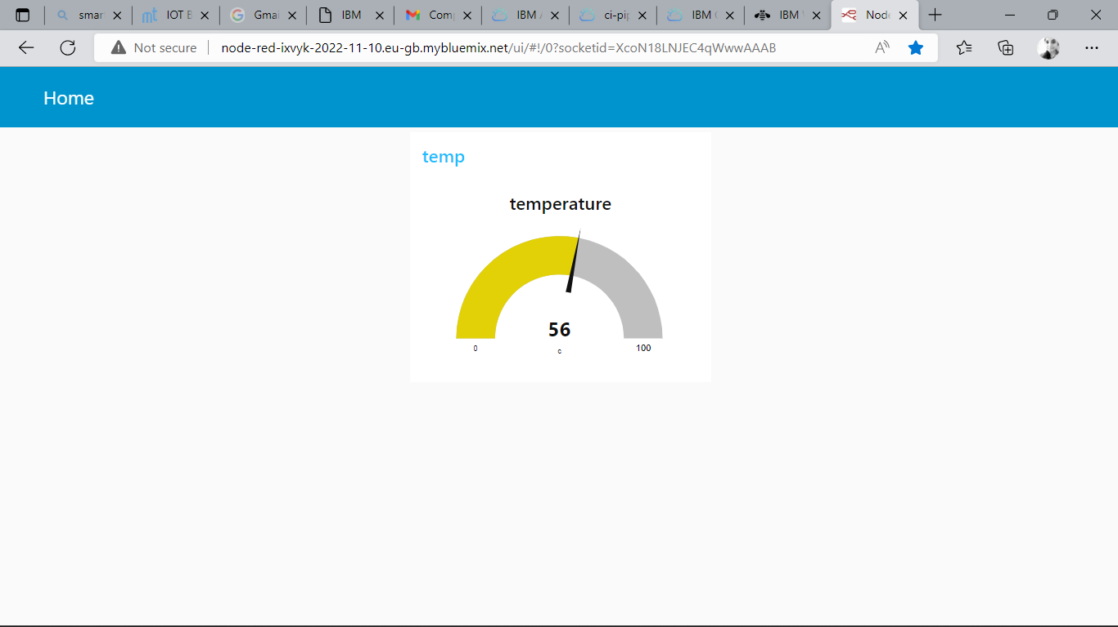

CODE : <http://node-red-ixvyk-2022-11-10.eu-gb.mybluemix.net/ui>

Web application is successfully completed